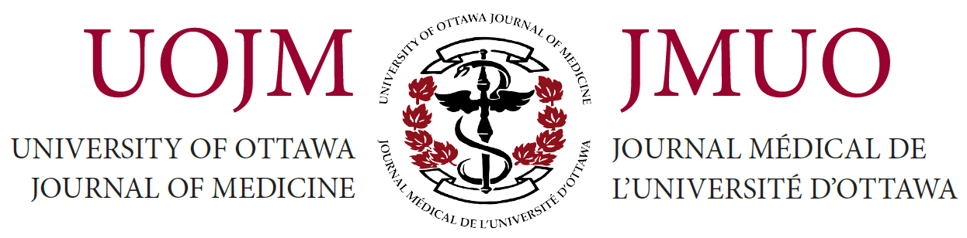

UOJM Editorial Team Application 2018–2019

First Name |  | Last Name

E-mail Address |  | Program |  | Year

Languages Spoken

Which position are you applying for?

Describe any relevant skills or experiences that have prepared you for this position.

What are your vision and goals for the upcoming year, and how would you like to improve UOJM next year?

The positions of reviewers and section editors can be time-consuming. How will you make sure to organize your time and fulfill your responsibilities?

